To activate simulation in KSL450:

1. In the Settings view, check demo mode:
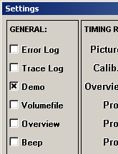

2. In the Configuration menu, select Simulate:
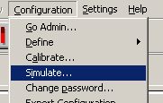

3. Select Tank, Measurement and Sensor. Check Simulate this sensor.
4. Enter min and max values as well as times (minutes) for up-ramp, down-ramp,
top and bottom.
5. Check Simulation ON.
6. Click on Save.
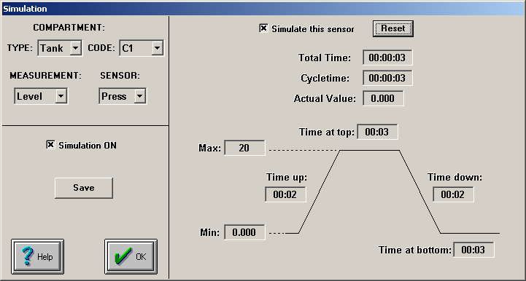

7. For automatic simulation mode, put “Simulate”,”1” in the startarg.sup file.
8. Simulation data is stored in the simdxxxx.xml file.

